# Section 13:2: The Second and Third Walking/Teaching Tours

In Section 13.1, we witnessed the Buddha take the first great steps in his teaching mission—transforming the five ascetics into his first disciples and establishing the Bhikkhu Saṅgha, which grew to sixty arahant disciples. During this profound period, he delivered two of the most revolutionary discourses in history: the Dhammacakkappavattana Sutta and the Anattalakkhaṇa Sutta, setting the Wheel of Dhamma in motion and revealing the nature of non-self.

The Blessed One then spent his first Rains Retreat (Vassa) at Isipatana, deepening his disciples' understanding of the path.

Now, we turn to the next phase of the Buddha’s mission—the Second and Third Walking Tours, during which he expanded his teachings further, met King Bimbisāra, and witnessed significant events that shaped the early Sangha.

## The Second Walking Tour: From Isipatana to Uruvelā

At the end of the first Vassa, the Buddha instructed his sixty arahant disciples to go forth into the world and spread the Dhamma:

“*Go forth, monks, for the welfare and happiness of many, out of compassion for the world… There are beings with little dust in their eyes who are wasting away because they have not heard the Dhamma. There will be those who understand.”[1]*

With this, the Buddha’s missionary movement began—his disciples dispersed in different directions, carrying the light of the Dhamma to those who were ready to receive it.

The Buddha, however, did not remain in Isipatana. His compassion led him toward Uruvelā, where he would continue to proclaim the liberating Truth:

*“I too will go to Uruvelā, to Senānigama, to proclaim the Teaching.” [2]*

This journey was not merely a physical one—it symbolized the Buddha’s unwavering determination to seek out those who had the potential for awakening. In Uruvelā, momentous encounters awaited him, including his meeting with King Bimbisāra, a ruler whose destiny was intertwined with the Dhamma.

In the next segment, we will explore these meetings and the profound impact they had on the spread of the Buddha’s teachings.

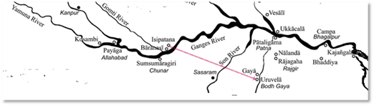

**Second Walking Tour of the Buddha- From Isipatana to Uruvelā [3]**

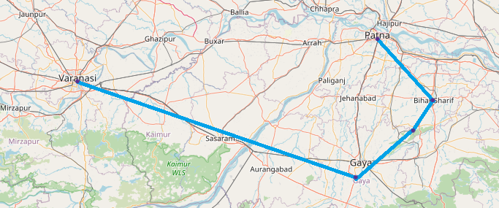

**Modern day map: distance from Varanasi to Gaya: about 248 km. [4]**

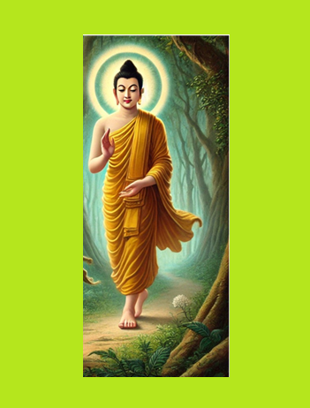

**The Buddha walking along through woodlands of Benares towards Uruvelā [5]**

## Insights from Other Sources on the Second Walking Tour [6]

After spending his first Rains Retreat (Vassa) at Isipatana, Migadāya, the Buddha conducted the Pavāraṇā ceremony, marking the conclusion of the retreat. Without delay, he set out for Uruvelā, a place that would soon witness another significant expansion of the Bhikkhu Saṅgha. During his stay in Uruvelā, which lasted three months, the Blessed One taught and guided the hermit brothers and their one thousand followers, leading them step by step toward the path of awakening.

Expansion of the Monastic Community [7]

As the Buddha journeyed from Isipatana to Uruvelā, he encountered a group of thirty young princes, known as the Bhaddavaggīya (the Fortunate Ones). These princes had set out in search of a missing woman but instead found something far greater—the Dhamma. [8]

Upon listening to the Buddha’s profound teachings, they experienced a deep realization and attained stream-entry (sotāpatti), the first stage of awakening. Moved by their newfound insight, they renounced worldly life and joined the Sangha, further strengthening the growing community of monks.

At this point, the monastic order had grown significantly: [9]

* 60 arahants from Isipatana
* 30 newly ordained Bhaddavaggīya monks
* Total: 90 monks

#### Dhamma Teaching:

This encounter also gave rise to a well-known Dhamma teaching:

**"Searching for oneself is far better than searching for others."**

When the Bhaddavaggīya princes explained their original quest, the Buddha posed a thought-provoking question:

**“What do you think is better—searching for a woman (or others), or searching for yourselves?”**

They immediately recognized that the search for self-understanding was far more meaningful than their external pursuits. This teaching highlights a profound truth—instead of looking outward for fulfillment, one should turn inward and cultivate wisdom, for it is through self-examination that one attains true liberation.

**The journey to Uruvelā was more than a physical passage; it was a continuation of the Buddha’s compassionate mission—guiding those who were ready to see the Truth and expanding the Saṅgha for the benefit of all beings.**

# Significant Events at Uruvelā – The Taming of the Jatilas

After completing his second walking tour, the Blessed One arrived at Uruvelā, [10] where he chose to stay at the monastery of Uruvelā Kassapa, [11] a prominent ascetic leader who practiced severe austerities. Kassapa was revered by many and led a community of 300 Jatila (dreadlocked ascetics), who deeply respected his spiritual attainments.

Despite his reputation, Uruvelā Kassapa harboured the mistaken belief that he himself was an arahant, and that the Buddha was not. Out of great compassion, the Blessed One sought to free him from his delusion and guide him toward true liberation.

## The Power of the Buddha’s Compassion – Subduing the Jatilas

To break Kassapa’s pride and open his mind to the truth, the Buddha manifested numerous miracles, each demonstrating his unmatched wisdom and supernormal abilities. These wonders were not performed for mere spectacle but as skilful means (upāya) to inspire faith and right understanding.[12]

Two of the most striking miracles recorded in the Vinaya Pataka were the Taming the Fire Serpent and Log-Splitting Incident:

* An encounter with a Naga serpent—a venomous dragon king who lived in the ‘Fire Hut’ of Uruvelā Kassapa. Taming of this serpent is described in Section:5.
* Log-Splitting Incident:
* The Buddha, through his spiritual mastery, prevented 500 logs from being split before he allowed them to be split.
* He stopped fires from being lit before allowing them to be lit.
* He halted them from being extinguished before allowing them to be extinguished.
* He even manifested 500 pans filled with hot coals, leaving the ascetics in awe.
* In total, the Buddha performed 3,500 such wonders, each revealing his profound power and wisdom. *[13]*

These miraculous events shattered Kassapa’s false sense of superiority. Realizing the Buddha’s immeasurable spiritual attainment, he humbly submitted and recognized that he was standing before the Fully Enlightened One.

## The Great Conversion – The Path to True Liberation

With his pride dissolved, Uruvelā Kassapa and his three-hundred (300) disciples opened their hearts to the Dhamma. Recognizing the futility of their past practices, they renounced their former ways and took refuge in the Buddha.[14]

After three months at the monastery of Uruvelā Kassapa, the Blessed One finally accomplished the great task of taming Uruvelā Kassapa, along with his two brothers, Nadī Kassapa and Gayā Kassapa, and their vast community of ascetic followers. These three brothers, once esteemed leaders of Jatila ascetics, had held firm to their practices, but through the Buddha’s wisdom, patience, and boundless compassion, they gradually realized the futility of their extreme austerities. In the end, the entire community of 1,000 ascetics renounced their former ways and entered the Buddha’s Sangha, marking one of the most significant mass ordinations in history.[15]

This moment was not just a personal transformation for Kassapa—it marked the conversion of an entire community of ascetics, who had once clung to extreme austerities but now walked the path of the Middle Way under the guidance of the Buddha. The taming of the Jatilas at Uruvelā stands as a powerful testament to the Buddha’s skilful means, boundless compassion, and unwavering dedication to leading beings from ignorance to wisdom.

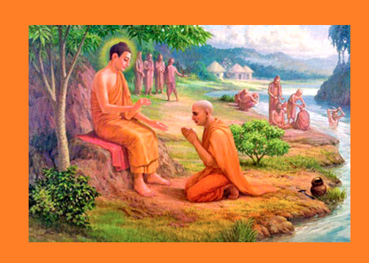

**Uruvela Kassapa and his Pupils becoming Disciples of the Buddha [16]**

This remarkable event highlights one of the nine noble qualities of the Buddha:

Anuttaro purisa-damma-sārathi – "**The unsurpassed trainer of those who can be trained.**"

As an extraordinary spiritual guide, the Buddha knew precisely how to break through delusions and lead beings to liberation, using skilful means (upāya) and wisdom (paññā) to transform even the most stubborn seekers. [17]

The scriptures affirm that the Blessed One remained in Uruvelā for three months, dedicating his time to taming and guiding Kassapa and his followers, ensuring their complete understanding of the Dhamma before setting out on his next journey.[18]

# The Third Walking and Teaching Tour – From Uruvelā to Rājagaha via Gayāsīsa

Following the conversion of the Kassapa brothers and their disciples, the Blessed One set out once again, leading his newly ordained 1,000 monks from Uruvelā to Gayāsīsa and then to Rājagaha.

This marks the **Third Teaching Tour** of the Buddha, as recorded in the Vinaya Piṭaka:

*“After staying at Uruvelā for as long as he wished, the Buddha went to Gayāsīsa together with that great Saṅgha of one thousand monks, all of them previously dreadlocked ascetics, and they stayed there…” [19]*

This journey signified not only the expansion of the Sangha but also the Buddha’s compassionate resolve to bring the Dhamma to those ready to receive it, guiding them step by step toward the highest peace—Nibbāna.

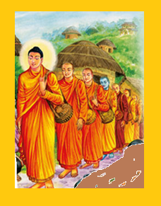

**The Buddha walking with large number of Sangha from Uruvelā to Gayāsīsa [20]**

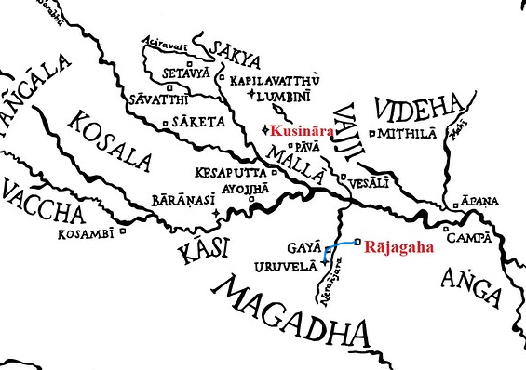

**Third Walking Tour of the Buddha [21]**

**The route**: Uruvelā to Gayasisa and then to Rajagaha. Uruvelā to Gaya is about 15 km

and Gaya to Rajgir 78 km.

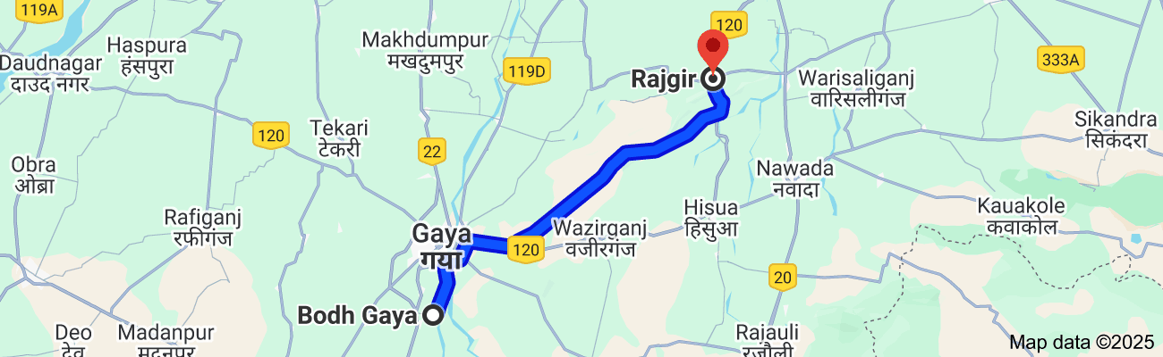

**Modern day map showing the route from Bodh Gaya to Gaya and then to Rajgir [22]**

**note**: according to present day maps of India, Bodh Gaya is the place of the enlightenment of the Buddha and Gaya (Gayāsisa) is town situated north of Bodh Gaya [23]

## The Fire Sermon at Gayāsīsa – A Profound Teaching on Liberation

Having tamed and guided the 1,000 former ascetics at Uruvelā, the Blessed One led them to Gayāsīsa (Gaya Head) as part of his Third Walking Tour. Here, amidst the natural stillness of the landscape, he delivered one of the most powerful and transformative discourses—the Ādittapariyāya Sutta, or the Fire Sermon. [24]

### The Reality of Burning – A Call to Awakening

In this discourse, the Buddha revealed a profound insight into the nature of all conditioned existence. He declared: [25]

**“Bhikkhus, everything is burning.”**

**What is burning?**

Everything that we experience—the six sense faculties (eye, ear, nose, tongue, body, and mind), the six external objects (forms, sounds, smells, tastes, touches, and thoughts), and the consciousness arising from their contact—is on fire.

**Burning with what?**

🔥 The **fire of craving (rāga)**  
🔥 The **fire of aversion (dosa)**  
🔥 The **fire of delusion (moha)**  
🔥 The **fires of birth, aging, and death**  
🔥 The **fires of sorrow, lamentation, pain, despair, and suffering**

This is not just a metaphor—it is a direct truth about the impermanent, unsatisfactory, and selfless nature of all phenomena. The worldly mind clings to these fleeting experiences, but in reality, they are consumed by flames, bringing suffering rather than true happiness.

### The Path to Liberation

When one truly sees this burning nature of existence, a deep sense of disenchantment (nibbidā) arises. No longer deceived by the illusion of pleasure in worldly attachments, the mind naturally let’s go.

➡ With disenchantment comes dispassion (virāga).  
➡ With dispassion, the mind is liberated (vimutti).  
➡ With liberation, true wisdom arises:

*"Birth is destroyed, the holy life has been lived, what had to be done has been done, there is no more coming to any state of being."[26]*

This teaching strikes at the root of suffering, offering a clear and direct path to Nibbāna—the unshakable peace beyond the fires of craving and attachment.

### A Thousand Monks Attain Arahantship

As the Buddha spoke, the words of truth penetrated deeply into the hearts of the 1,000 monks. With perfect clarity, they realized the burning nature of all conditioned things and, at that very moment, their minds were completely liberated from all fetters.

**They attained arahantship—full awakening!**

This event at Gayāsīsa was not only a turning point for these monks but also a testament to the power of the Buddha’s wisdom. The Fire Sermon remains one of the most striking and transformative discourses, guiding countless beings toward the cooling peace of Nibbāna, where all fires of suffering are extinguished forever.

## Expansion of the Bhikkhu community

Earlier we saw that Buddha has about ninety (90) disciples—five group of monks + Yasa and his friends 60 + 30 of Bhaddavaggiya princes. With the addition of 1000 newly ordained bhikkhus he had about 1090 disciples. We see this as a random number because earlier in section 13-1 we saw how the Buddha allowed his monks to teach and ordain (the missionary service), hence by this time the Bhikkhu Sangha may have been expanded!

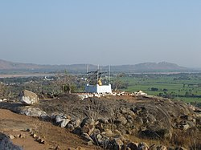

**Present day picture of Gayasisa or Brahmayoni hill, where Buddha taught the Fire Sermon** [27]

With the following statement from Vinaya Pitaka, we will end this section:

“*After staying at Gayāsīsa for as long as he liked, the Buddha set out wandering toward Rājagaha with large sangha of one thousand monks, all of them previously dreadlocked ascetics. When he eventually arrived, he stayed in the cane grove at the Suppatiṭṭha Shrine”[28]*

The next section (14-1) will focus on the Buddha meeting King Seniya Bimbisāra of Magadha and related events.

### Endnotes: Section 13-2

1. VP: Mahākandaka 8: Translated by Bhikkhu Brahmali.
2. Ibid.
3. An imagination of an artist about the route of 2nd walking tour.
4. Google Maps.
5. AI generated image.
6. **See**: Maha Buddhavamsa- The Great Chronicle of Buddhas- Part 1- by Ven. Mingun Sayadaw
7. VP: Mahākandaka 11.
8. Ibid. * There story was elaborated in here. Those thirty princes had gone picnicking with their wives in a forest glade between [Bārāṇasi](https://www.aimwell.org/DPPN/baranasi.html) and [Uruvelā](https://www.aimwell.org/DPPN/uruvela.html). One of them had no wife, and for him they found a courtesan; but she awaited the opportunity and ran away with their goods. While seeking for her, they saw the Buddha and enquired if he had seen a woman. However, he answered, should they not rather seek the “self” than a woman. They all agreed thereto, and the Buddha taught Dhamma. See: Dictionary of Pāli Proper Names by G.P. Malalasekera, <https://www.aimwell.org/DPPN/isipatana.html>
9. Ibid.
10. VP: Mahākandaka 12.* The monastery of Uruvela Kasspa was situated near by Neranjana river.
11. One of three brothers, the Tebhātika-Jaṭilā, living at Uruvelā. He lived on the banks of the [Nerañjarā](https://www.aimwell.org/DPPN/neranjara.html) with five hundred disciples. Further down the river lived his brothers [Nadī-Kassapa](https://www.aimwell.org/DPPN/nadi-kassapa.html) with three hundred disciples and [Gayā-Kassapa](https://www.aimwell.org/DPPN/gaya-kassapa.html) with two hundred: source: Dictionary of Pāli Proper Names by G.P. Malalasekera.
12. VP: Mahākandaka 12
13. VP: Mahākandaka 12 * A detailed description of miracles is described here.
14. VP: Mahākandaka 12
15. VP: Mahākandaka 12
16. Source: <https://www.budusarana.lk/budusarana/2016/09/09/tmp.asp?ID=fea05>: Budusarna News Paper, Sri Lanka: 9/9/2016.
17. See: Part 1 - The Buddha’s visit to Rājagaha, [Maha Buddhavamsa—The Great Chronicle of Buddhas](https://www.wisdomlib.org/buddhism/book/the-great-chronicle-of-buddhas)

    by Ven. Mingun Sayadaw. It is also mentioned here that by the power of  [*sabbaññutā*](https://www.wisdomlib.org/definition/sabbannuta#pali)*-*[*ñāṇa*](https://www.wisdomlib.org/definition/nana#theravada) (omniscience) the Blessed One tamed Urivela Kassapa. There is also reference to a Jataka story how the bodhisattva -then born as Brahma Narada tamed King [Anga](https://www.wisdomlib.org/definition/angati#theravada)ti, who was Uruvela Kassapa in former life.
18. VP: Mahākandaka 12
19. VP: Mahākandaka 12.
20. Source: <https://www.budusarana.lk/budusarana/2015/01/20/tmp.asp?ID=fea08>

    Budusarana News Paper, Sri Lanka: 210/1/2015
21. Imagination of an artist of the route taken in 3rd tour. Map source: <https://suttacentral.net/>
22. Google Maps.
23. Gaya (*Gayā*) is a city, municipal corporation and the administrative headquarters of [Gaya district](https://en.wikipedia.org/wiki/Gaya_district) and [Magadh division](https://en.wikipedia.org/wiki/Magadh_division) of the Indian state of [Bihar](https://en.wikipedia.org/wiki/Bihar). Bodh Gaya ("Buddha Gaya"), so named to distinguish it from the Hindu town centre of Gaya, is one of the four holiest sites of Buddhism and the site where the Buddha attained enlightenment: Source: <https://en.wikipedia.org/wiki/Bodh_Gaya>
24. VP: Mahākandaka 12.
25. VP: Mahākandaka 12 and SN35:28 give detail description of this sutta.
26. VP: Mahākandaka 12 and SN35:28 give detail description of this sutta
27. Source: <https://en.wikipedia.org/wiki/%C4%80dittapariy%C4%81ya_Sutta>
28. VP: Mahākandaka 13: The account of meeting with Bmbisara.